1.WRITE A JAVA CODE FOR ARTHEMETIC OPERATIONS

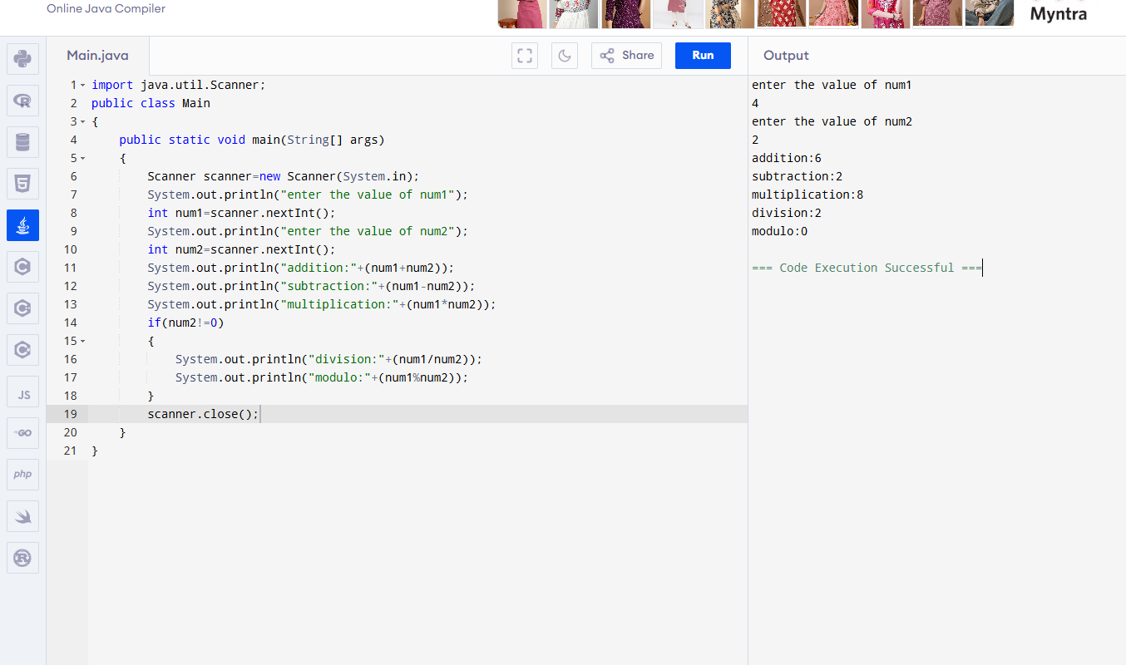

2.WRITE A JAVA PROGRAM TO DISPLAY THE CLASS GRADES

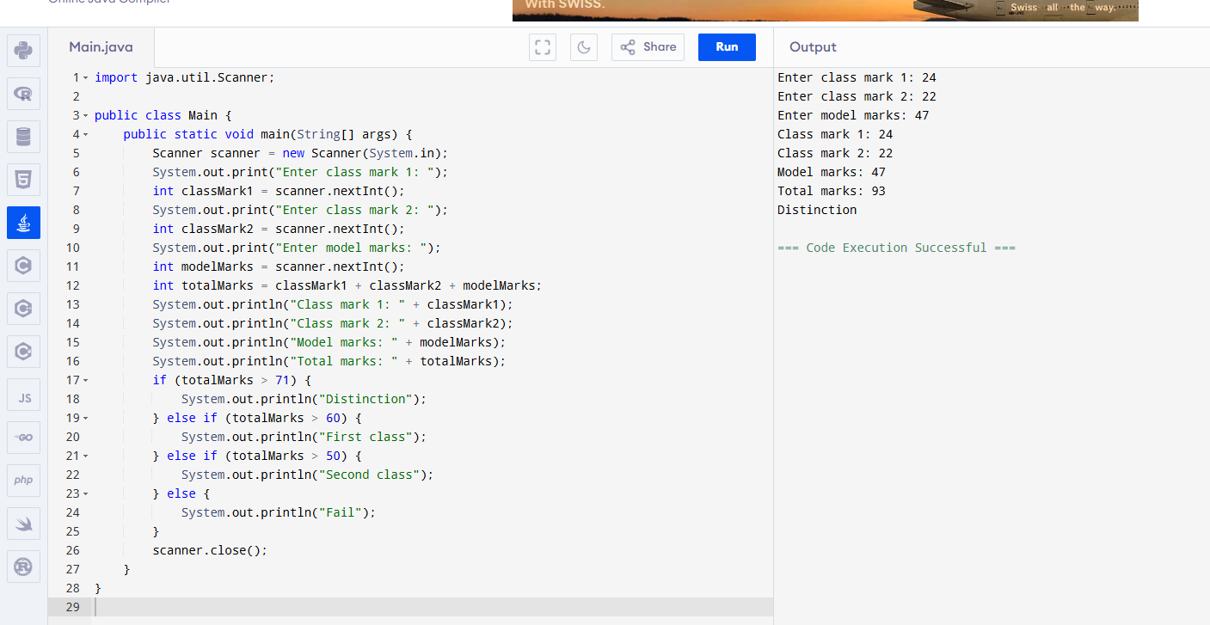

3.WRITE A JAVA PROGRAM TO SIMPLE INTREST AND COMPUND INTREST.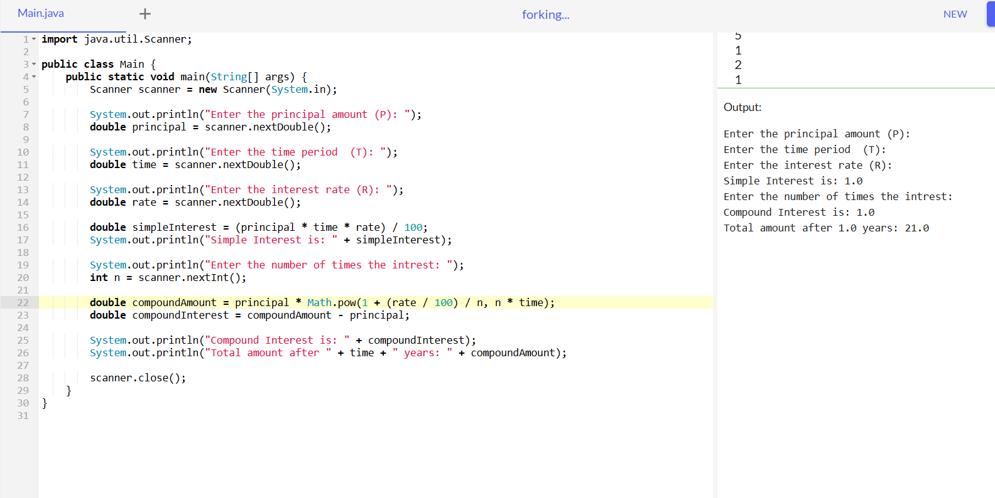.

4.WRITE A JAVA PROGRAM TO DISPLAY MONTHS USING NUMBERS 1 TO 12.

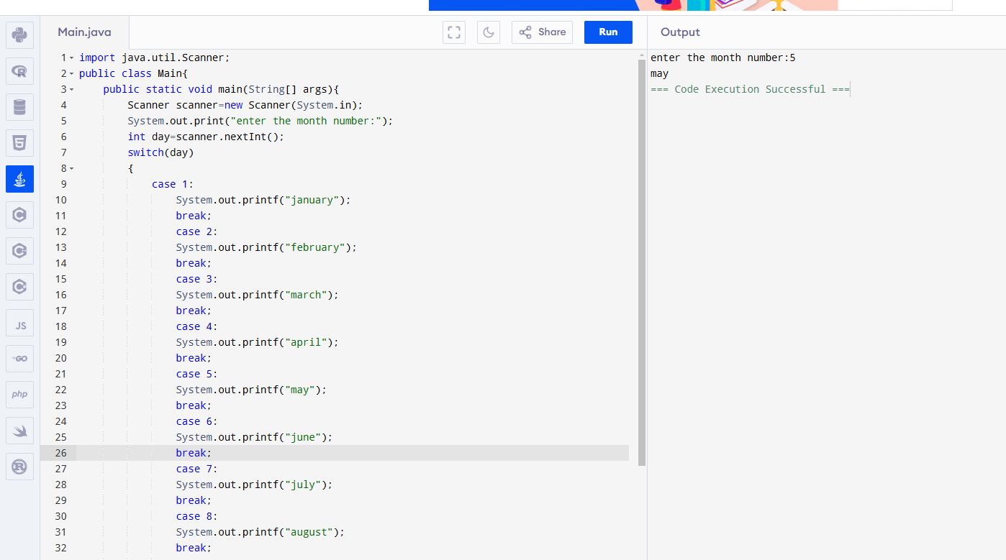

5.WRITE A JAVA PROGRAM TO DISPLAY THE REVERSE WORD,UPPER CASE ,LOWER CASE,LENGTH OF THE STRING.

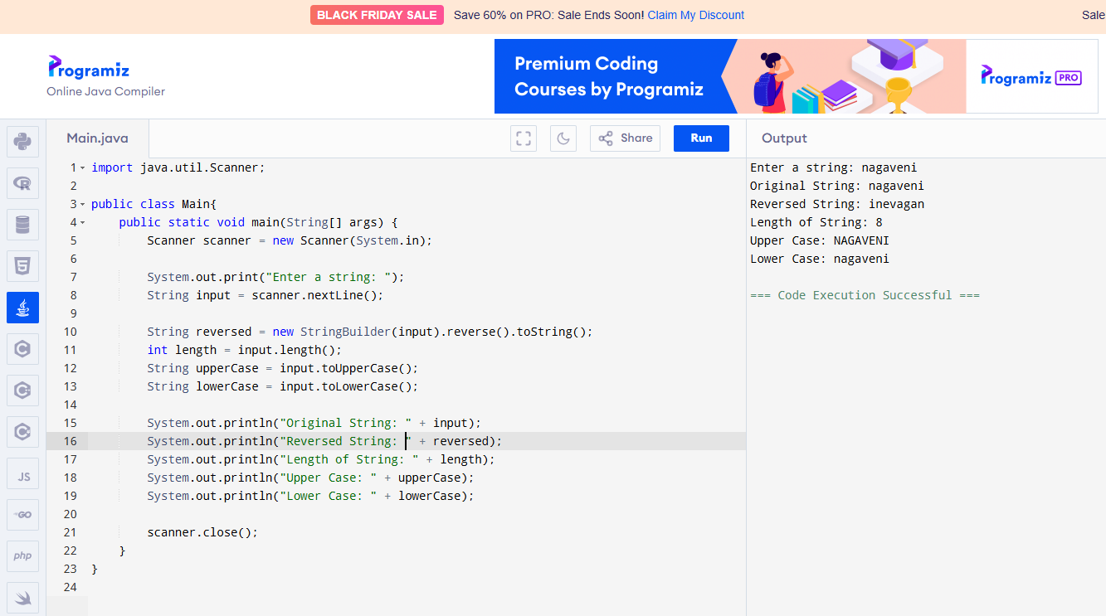

6.WRITE A JAVA PROGRAM TO DISPLAY THE SALARY DETAILS LIKE NET SALARY,TAX,CONVIENCE ALLOWANCE AND FINAL SALARY.

